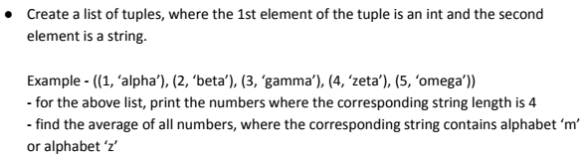

**Screenshot of Program and Output:-**

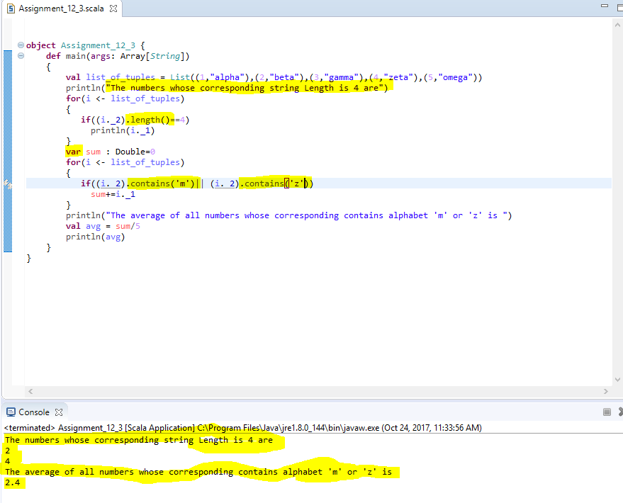

**Explanation:-**

* I have declared the list of tuples and assigned to variable name **list_of_tuples.**
* Now using for loop, for each tuple ‘i’ in ‘list_of_tuples’, I have printed the corresponding numbers whose string length is 4 with the help of **length()** function.
* Again using for loop, we have calculated sum and average of tuples that contains string with letters ‘m’ or ‘z’ with the help of **contains()** function.

**Program code:-**

**object** Assignment_12_3 {

**def** main(args: Array[*String*])

{

**val** list_of_tuples = List((1,"alpha"),(2,"beta"),(3,"gamma"),(4,"zeta"),(5,"omega"))

println("The numbers whose corresponding string Length is 4 are")

**for**(i <- list_of_tuples)

{

**if**((i._2).length()==4)

println(i._1)

}

**var** sum : Double=0

**for**(i <- list_of_tuples)

{

**if**((i._2).contains('m')|| (i._2).contains('z'))

sum+=i._1

}

println("The average of all numbers whose corresponding contains alphabet 'm' or 'z' is ")

**val** avg = sum/5

println(avg)

}

}